1. Solve the below crossword
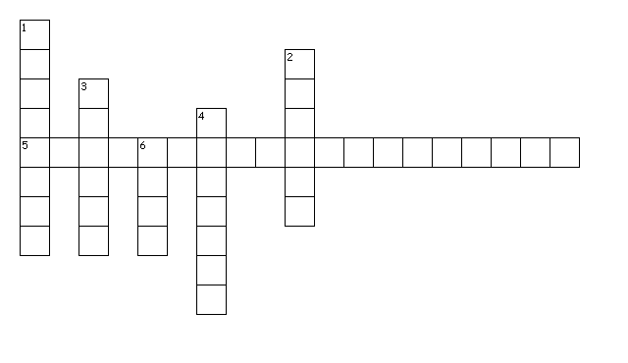Across
5. Comes out of leaves in the form of vapour and this is called
Down
1. Arrangement of veins on the leaf
2. This part of flower has stigma, style ovary
3. This part of flower has anther and filament
4. Root has parallel venation
6. It holds the plant upright

